Vacation Tracker App ReadMe

Vacation tracker is an application for requesting Vacations in a company. It is using Angular Material Design by Google and Kinvey console as a backend service.

Vacation tracker has three different roles with different rights:

1. User role – users can :
   * Request vacations, provide reason for the vacation;
   * Cancel their own vacations before they are due (before their start date);
   * Search in previous and next vacations;
   * Look up all team members’ vacations in the Team Calendar page and plan accordingly their vacations;
   * Check their left paid days for the year (20 days for each year);
   * At registration paid days are calculated per month left for the current year (1.66 days per month, for example if user register August they have 1.66 * 5 months = 8.3 ~ 8 days left;
2. Manager role –
   * Managers can approve and reject vacation requests
   * All the stuff users can do;
3. HR role –
   * HRs can set up user profile and change vacation days left for each user;
   * HRs can do all of the stuff of the user;

Screenshots from the Vacation tracker:

**Figure 1: Request vacation screen (Home page)**

Login as a **user (Kosta)** with **pass (123456)** and you are greeted with the request vacation screen. Here you can fill your details of the vacation and request it.

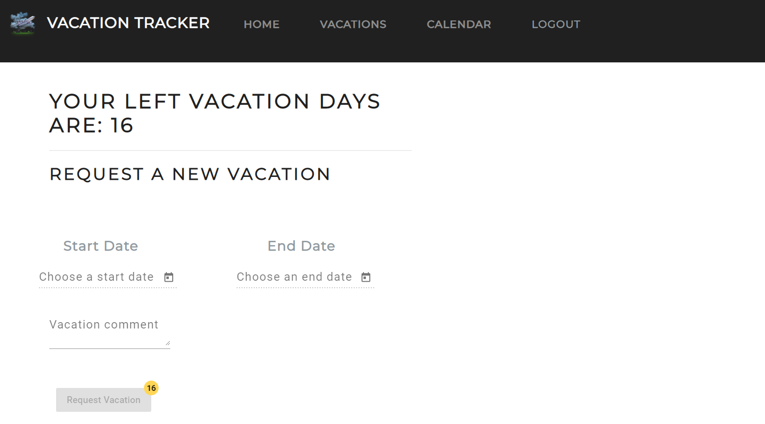

**Figure 2: Filling request vacation form.**

Days before today cannot be requested as a start date and after you select start date, you cannot select date before the start date. After you select both dates, you need to provide a comment and then the “Request vacation” button is enabled, otherwise it is disabled.

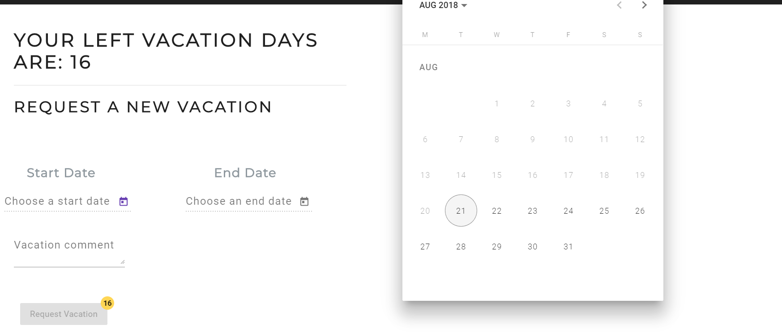

**Figure 3: Filled form:**

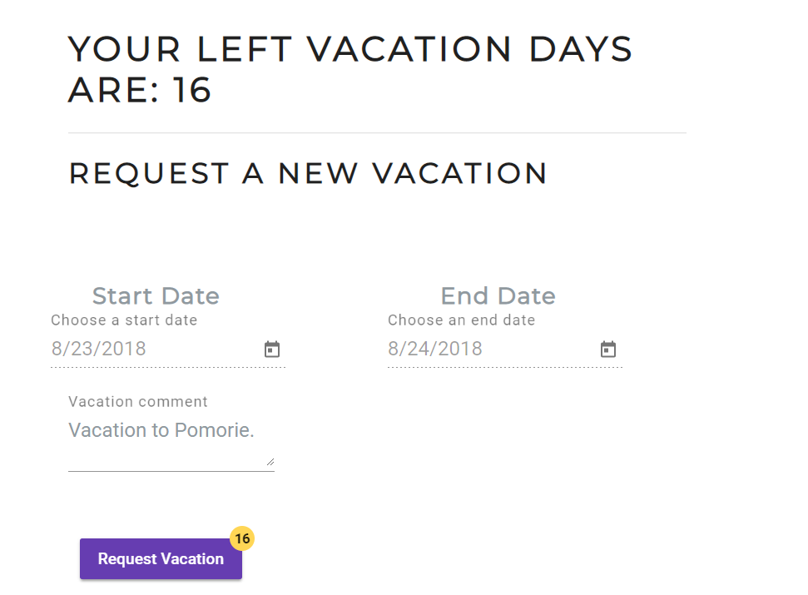

After you request your vacation, the days are automatically updated:

**Figure 4: Updated paid vacation days after request is made**



**Figure 5: Previous and Next Vacations Page**

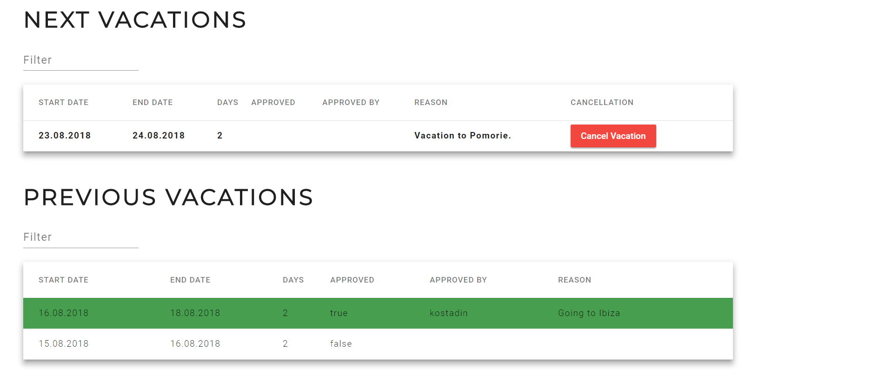

At my vacations page you can search in the previous and next vacations and check if your vacation is approved and if it is still upcoming you can cancel your vacation and your days are returned back.

**Approved vacations** are highlighted in **Green color** and **rejected** are in **Red color.**

**Figure 6: Full text search in vacations table:**

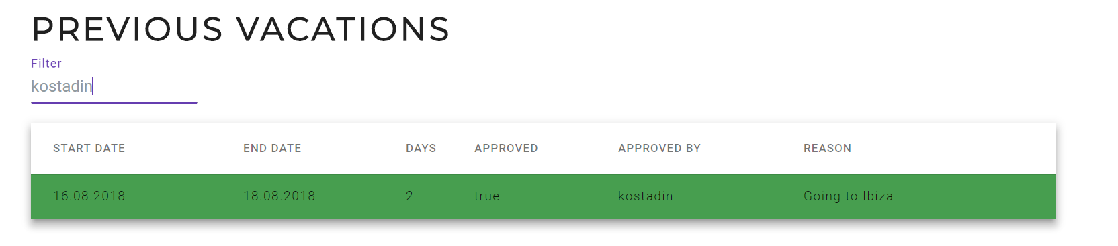

**Figure 7: Team Calendar Page**

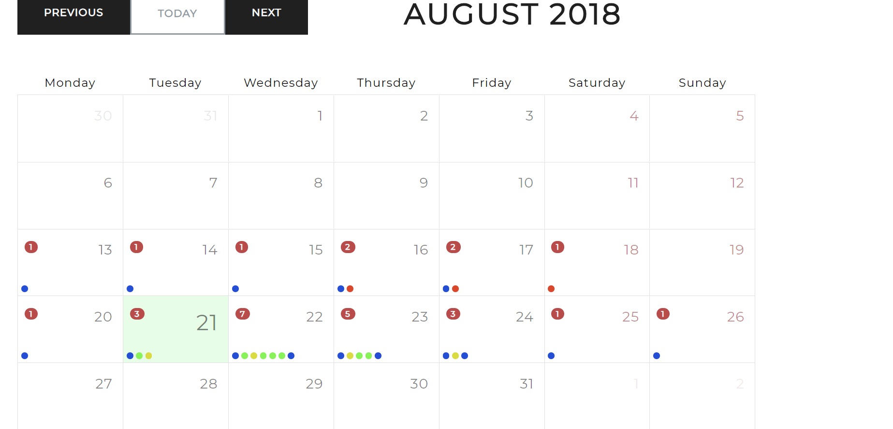

At team calendar, a user can **see all team members approved and not cancelled vacations** and each team member is highlighted in different color.

**Figure 8: Day view from Team Calendar**

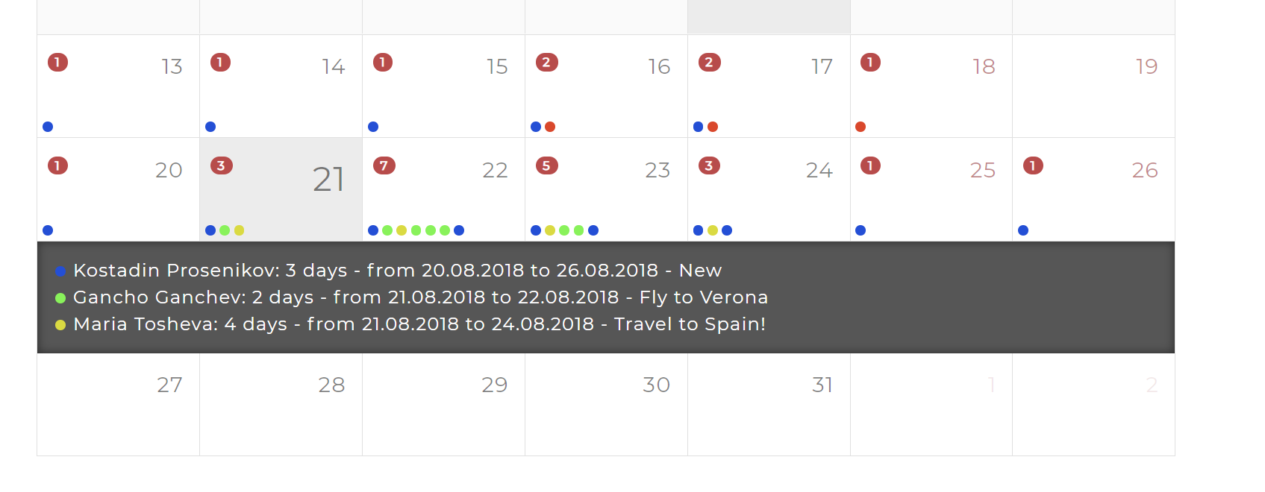

Here each user can see all team members, who have taken vacations, who is each team member, for how long, the start and end dates and the reason for the travel.

Keep in mind that here users can see only the approved and not cancelled vacations from each user.

**Figure 9: HR role: HR admin page:**

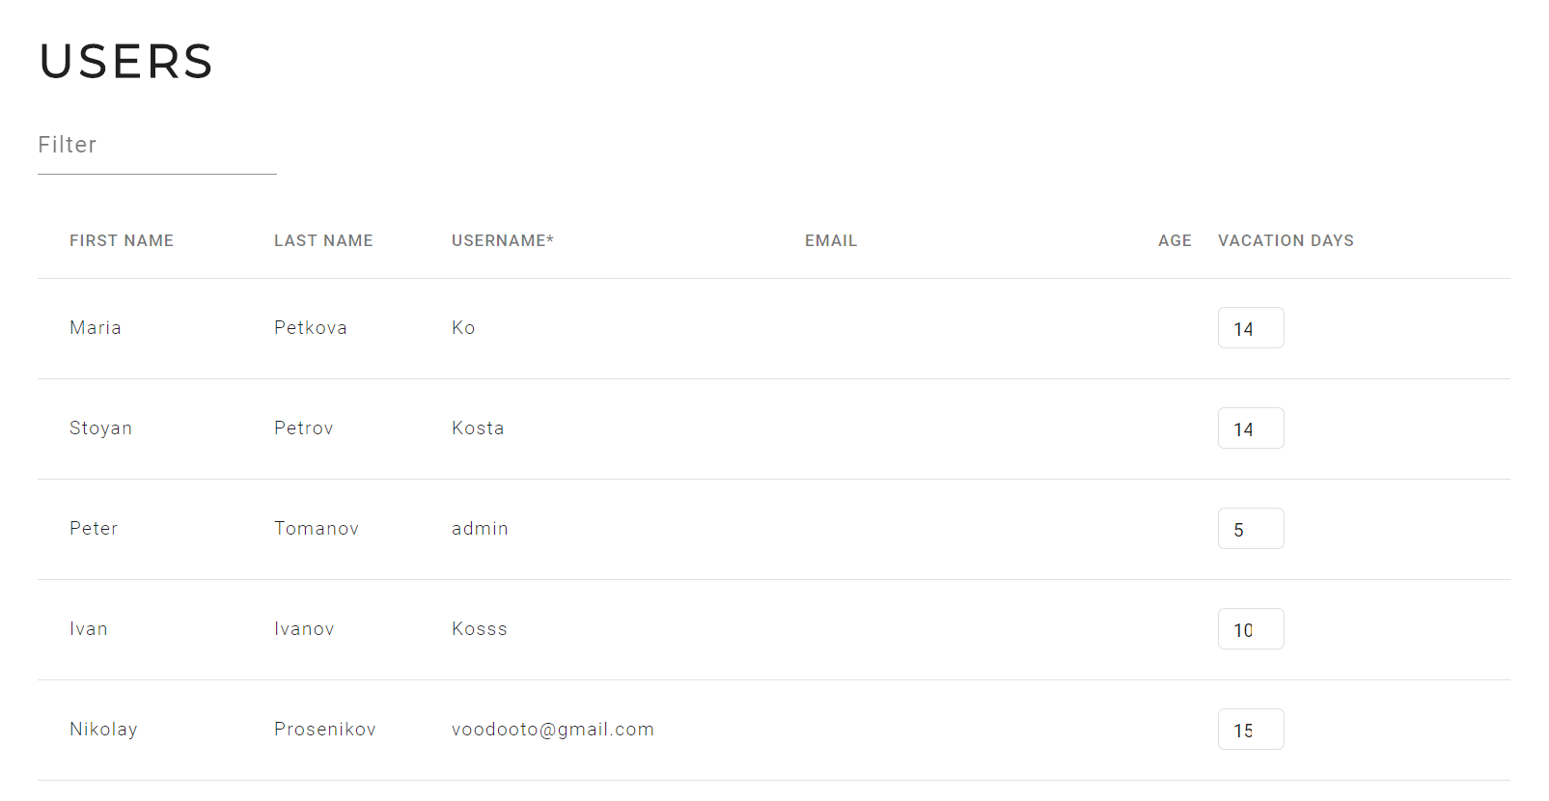

HRs can search for each user here, set up details and change the vacation days for each user.

**Figure 10: Manager Role: Approval page**

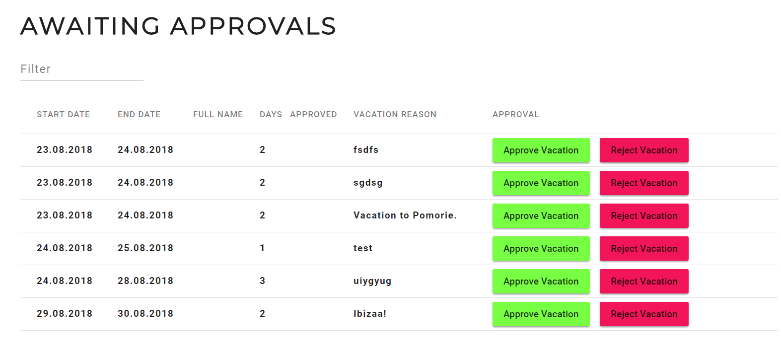

Each manager can approve or reject all of the pending vacation requests. Either by selecting approve or reject they can approve or reject a vacation and then the user can see in his vacations view that his vacation is approved or rejected.

In future I plan to add approve or reject reason, because when a manager rejects a vacation request, he needs to provide a reason for this. For example a lot of work in the office. This is yet to be implemented.

**Figure 11: Approved request**

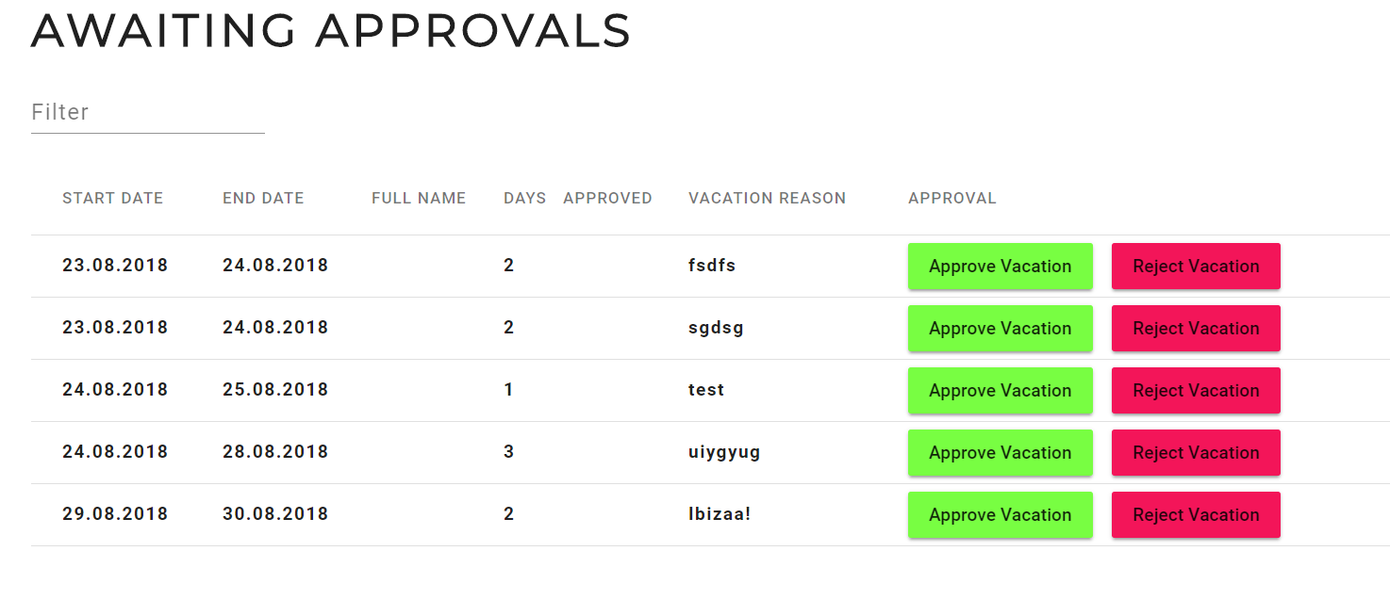

By selecting, approve on our vacation to Pomorie, the vacation request is gone from the approval queue and the queue is updated with the left requests in the Managers’ approval page. Additionally managers can search for a specific vacation (there is full table search here). For example if someone has asked why there is nothing happening with my request, the manager can look up his request and then either approve or reject it.

The user can now see their vacation in the vacations page.

**--------------------------------------------------------------------------------------------------------------------------------------**

**This is the Vacation Tracker Application by Kostadin Prosenikov.**

**GitHub Repo**: [https://github.com/KostaProsenikov/vacationTracker](https://github.com/KostaProsenikov/vacationTracker%20)

**--------------------------------------------------------------------------------------------------------------------------------------**